# CLASSIFICATION OF ARRHYTHMIA BY USING DEEP LEARNING WITH

# 2-D ECG SPECTRAL IMAGE REPRESENTATION

**A PRIEE REPORT**

***Submitted by***

|  |  |
| --- | --- |
| **HARISH K P (111720102040)** |  |
| **JAYANTH J J (111720102047)** |  |
| **KARTIKEY MISHRA (111720102055)** |  |
| **CIBIYARASU S (111720102030)** |  |
| **BAAJI V (111720102016)** |  |

***in partial fulfillment for the award of the degree of***

# BACHELOR OF ENGINEERING

## IN

**COMPUTER SCIENCE AND ENGINEERING**

**R.M.K. ENGINEERING COLLEGE**

### (An Autonomous Institution)

#### R.S.M. Nagar, Kavaraipettai-601 206



**November 2023**

R.M.K. ENGINEERING COLLEGE

(An Autonomous Institution)

R.S.M. Nagar, Kavaraipettai-601 206

**BONAFIDE CERTIFICATE**

Certified that this project report “**Classification of Arrhythmia by Using Deep Learning with 2-D ECG Spectral Image Representation**” is the bonafide work of **HARISH K P (111720102040), JAYANTH J J (111720102047), KARTIKEY MISHRA (111720102055), CIBIYARASU S (111720102030), BALAJI V (111720102016)** who carried out the 20CS513 Mini Project and Design Thinking work under my supervision.

|  |  |
| --- | --- |
| **SIGNATURE**  **Dr. T. Sethukarasi, M.E., M.S. Ph.D., Professor and Head**  Department of Computer Science and Engineering  R.M.K. Engineering College  R.S.M. Nagar, Kavaraipettai, Tiruvallur District– 601206. | **SIGNATURE**  **Ms.S.D.Lalitha**  **Supervisor**  Assistant professor  Department of Computer Science and Engineering  R.M.K. Engineering College  R.S.M. Nagar, Kavaraipettai,  Tiruvallur District–601206. |

Submitted for the Project Viva–Voce held on ……………………… at **R.M.K. Engineering College**, Kavaraipettai, Tiruvallur District– 601206.

#### INTERNALEXAMINER

**ACKNOWLEDGEMENT**

We earnestly portray our sincere gratitude and regard to our beloved **Chairman Shri. R. S. Munirathinam, our Vice Chairman, Shri. R. M. Kishore** and **our Director, Shri. R. Jyothi Naidu,** for the interest and affection shown towards us throughout the course.

We convey our sincere thanks to our **Principal**, **Dr. K. A. Mohamed Junaid,** for being the source of inspiration in this college.

We reveal our sincere thanks to our **Professor and Head of the Department, Computer Science and Engineering, Dr. T. Sethukarasi,** for her commendable support and encouragement for the completion of our project.

We would like to express our sincere gratitude for our Mini Project Coordinator **Ms. P. Baby Shamini, Assistant Professor**and project guide Ms.S.D.Lalitha,assistant professor for their valuable suggestions towards the successful completion for this project in a global manner.

We take this opportunity to extend our thanks to all faculty members of Department of Computer Science and Engineering, parents and friends for all that they meant to us during the crucial times of the completion of our project.

## TABLE OF CONTENTS

|  |  |  |
| --- | --- | --- |
| **CHAPTER** | **TITLE** | **PAGE NO** |
|  | **ABSTRACT** | 5 |
|  | **LIST OF FIGURES** | 6 |
| **1** | **INTRODUCTION** | 7 |
|  | 1.1 Problem Statement | 7 |
|  | 1.2 Project Scope and Objectives | 7 |
| **2** | **OVERALL DESCRIPTION** |  |
|  | 2.1 Project Specification | 8 |
|  | 2.2 Use Case Diagrams | 9 |
|  | 2.3 Design | 10 |
|  | 2.4 System Architecture | 11 |
| **3** | **EXTERNAL INTERFACE REQUIREMENTS** | |
|  | 3.1 User Interfaces | 12 |
|  | 3.2 Hardware Interfaces | 12 |
|  | 3.3 Software Interfaces | 13 |
| **4** | **TESTING** |  |
|  | 4.1 Test Plan | 14 |
|  | 4.2 Test Procedure | 14 |
|  |  |  |
| **5** | **FUTURE ENHANCEMENTS** | 15 |
| **6** | **CONCLUSION**  **REFERENCES**  **SAMPLE CODING**  **SCREENSHOTS** | 16 |
|  |  |  |

**ABSTRACT**

Traditional ECG analysis primarily relies on manually engineered features, potentially missing subtle but crucial patterns. In contrast, our approach transforms ECG signals into 2-D spectral images, encapsulating both temporal and spectral information. Deep learning models, including convolutional neural networks (CNNs) and recurrent neural networks (RNNs), process these images. Trained on diverse arrhythmia data, these models autonomously learn discriminative features, outperforming traditional methods with higher accuracy, sensitivity, and specificity.

In this study, we introduce an innovative approach to improve the accuracy and interpretability of arrhythmia classification. Cardiac arrhythmias are a significant health concern, demanding timely and precise diagnosis for effective patient care. Our method leverages deep learning techniques alongside a unique 2-D ECG spectral image representation.

Moreover, the use of 2-D ECG spectral images enhances interpretability, allowing clinicians to visualize the learned features and build trust in automated arrhythmia detection systems. This approach shows promise in revolutionizing arrhythmia diagnosis, potentially leading to improved patient care and outcomes. Further research and development in this direction hold significant potential for the healthcare industry.

## LIST OF FIGURES

|  |  |  |
| --- | --- | --- |
| **FIG.NO** | **FIGURE NAME** | **PAGE NUMBER** |
| 1. | Use case diagram | 9 |
| 2. | design | 10 |
| 3. | System architecture | 11 |

**CHAPTER 1 INTRODUCTION**

* 1. **Problem Statement**

The main problem is that to identify a specific medical condition known as Arrhythmia, also known as dysrhythmia, which is characterized by an abnormal heart rhythm or heartbeat. Normally heartbeat will be detected in a regular pattern but in arrhythmia this pattern has be disturbed which leads to irregular heartbeats such as too fast (tachycardia), too slow (bradycardia), or irregular in their rhythm. Thus, these irregular heartbeats lead to various problems like Reduced Cardiac Output, Blood Clots, Heart Failure, Angina (Chest Pain), Sudden Cardiac attack. Thus, our project is to identify understand these Arrhythmia pattern and take precaution measures for it.

## Project Scope and Objective:

#### Scope of the Project:

The project scope is to identify the Arrhythmia condition of a patient by analyzing the medical repots which have in image format. Additionally, a brief report of the arrhythmia condition has been shown in a visual format which helps us to understand it in a better.

## Objective of the Project:

The basic objective of our project is to develop an automated system which can able to detect the different types of Arrhythmias in a more accurate and effective manner from the electrocardiogram (ECG) data provided. Furthermore, this approaches the deep learning techniques and transforms the ECG signals into 2-D spectral images to understand the classification process.

# CHAPTER 2

**OVERALL DESCRIPTION**

**2.1 EXISTING SYSTEM**

To identify and analyze the Arrythmia condition, there have been various methods proposed for it, some of them are listed below:

**Atrial Fibrillation Detection using Deep Learning:**

Researchers have developed deep learning models to detect atrial fibrillation (AFib) from wearable ECG devices. These projects aim to enable early detection and monitoring of AFib, a common arrhythmia associated with stroke risk.

**Cardiac Arrhythmia Detection Challenge (PhysioNet):**

PhysioNet has hosted challenges that involve the development of machine learning and deep learning algorithms to automatically classify a wide range of arrhythmias from ECG data.

**Smartphone-Based Arrhythmia Detection Apps:**

Various projects have focused on creating smartphone applications equipped with ECG sensors for arrhythmia detection and monitoring. These apps aim to provide accessible and convenient arrhythmia screening.

**Implantable Cardiac Devices:**

Companies and research institutions continue to advance the capabilities of implantable devices like ICDs and pacemakers to better detect and classify arrhythmias, enhancing patient care.

**Machine Learning for Remote Monitoring:**

Several healthcare providers and tech companies are developing remote monitoring systems that use machine learning to analyze ECG data from patients at home, allowing for early arrhythmia detection and intervention.

**Deep Learning Research for Arrhythmia Classification:**

Academic and industry researchers are continually working on deep learning models for arrhythmia classification. These projects often aim to improve the accuracy and speed of diagnosis.

**2.2 PROPOSED SYSTEM**

In our proposed system, transactions will undergo real-time monitoring, and their fraud risk levels will be assessed using Artificial Intelligence algorithms. If a transaction's risk level exceeds a predefined threshold, the associated account will be frozen. This will be accomplished using the Random Forest Classifier. Additionally, our project encompasses the process of analyzing vast amounts of client data to extract valuable insights for loan risk prediction. When addressing credit risk, we will explore a method that investigates the causes and effects of mortgage credit risk on credit defaults. This approach will involve the use of various algorithms such as logistic regression, decision trees, support vector machines, Naïve Bayesian, and k-nearest neighbors.

**2.3 USECASE DIAGRAM**

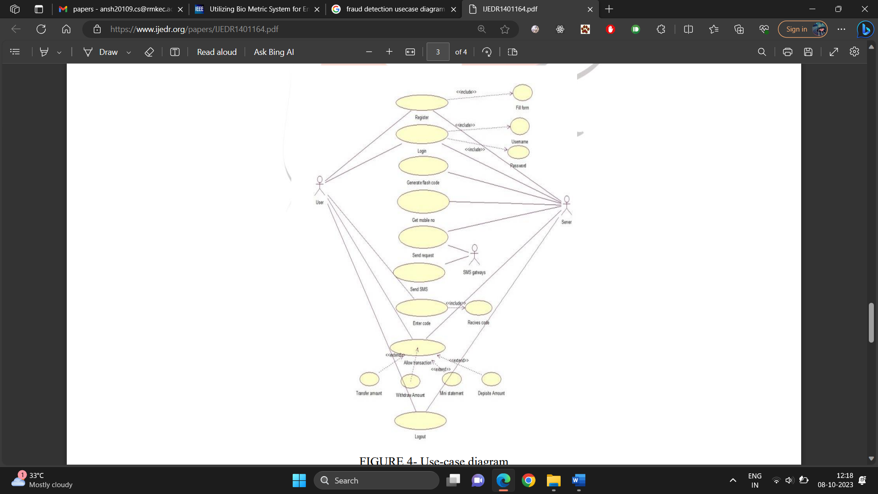

**2.4** **DESIGN**

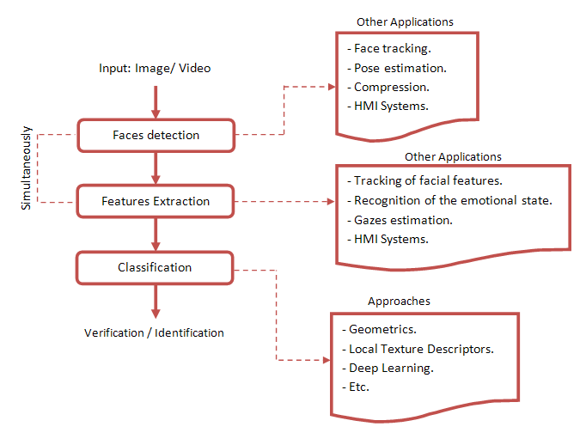

**2.6 SYSTEM ARCHITECTURE**

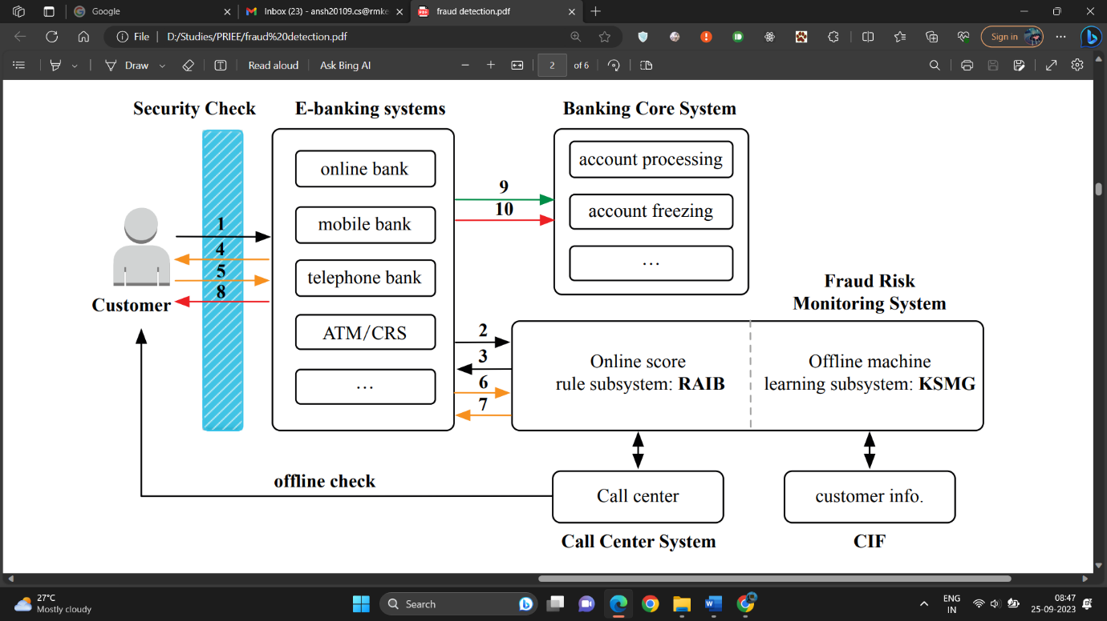

Fraud Transaction Detection

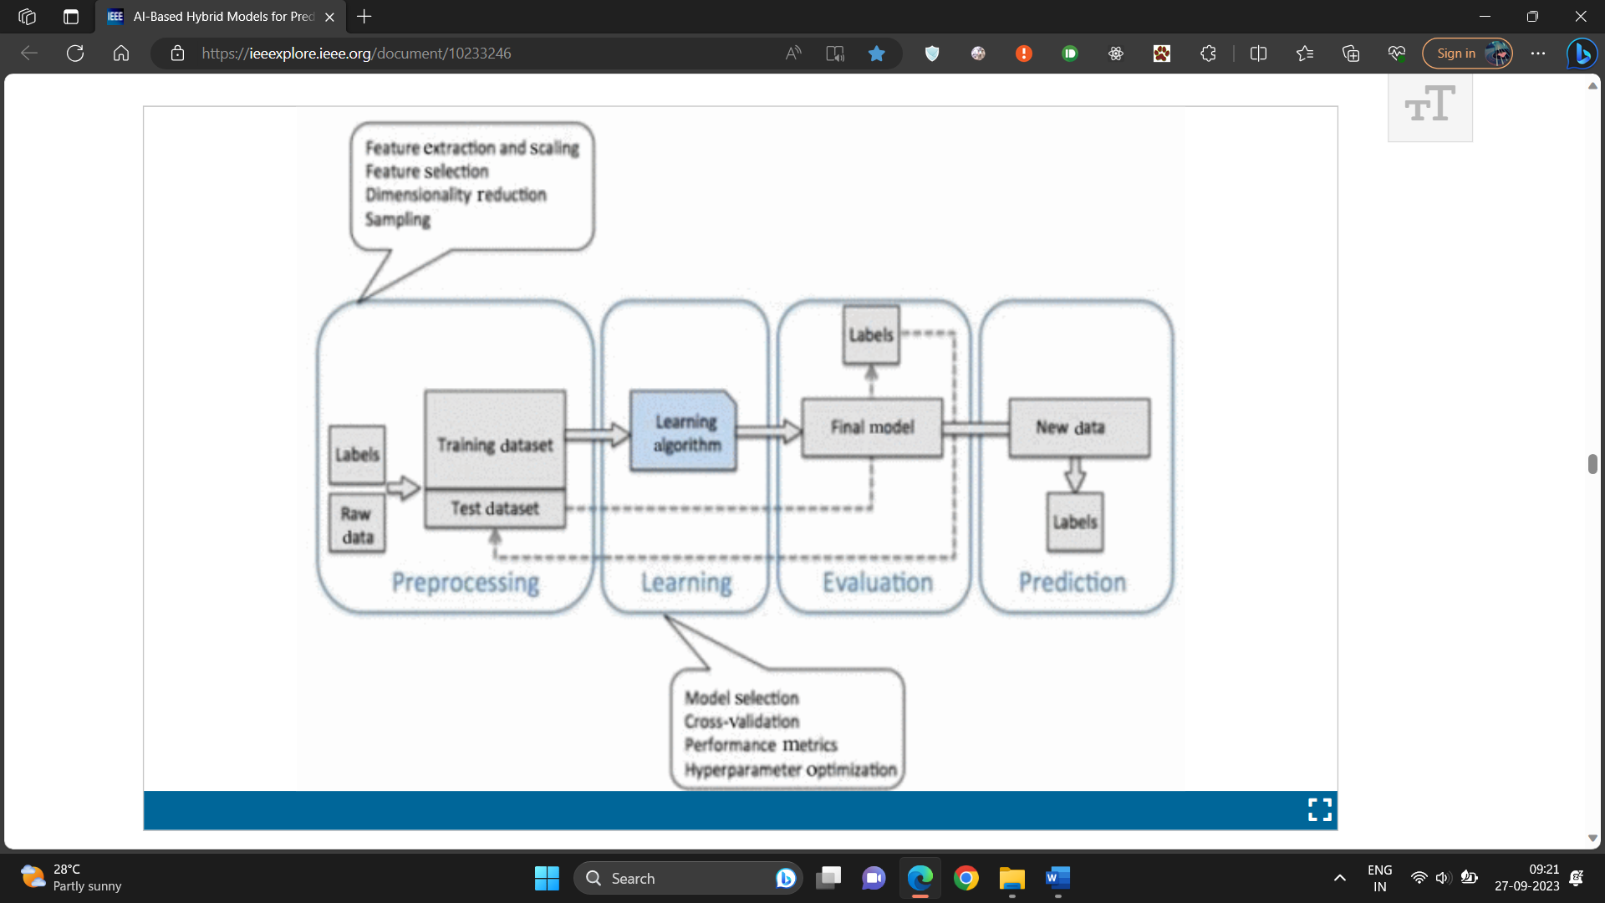

Loan Risk Prediciton

**CHAPTER 3**

**LITERATURE SURVEY**

|  |  |  |  |  |  |  |
| --- | --- | --- | --- | --- | --- | --- |
| S. NO | NAME OF THE JOURNAL | ALGORITHMS | PARAMETER 1 | PARAMETER 2 | PARAMETER 3 | PARAMETER 4 |
| 1 | Performance, Efficiency, and Target Setting for Bank Branches : Time Series With Automated Artificial Intelligence, Iiker Met, 2022 | Last Value Naïve, Seasonal Naïve, Average Value, Naïve Zeroes, Naïve GLS. | Sensitivity | Specificity | Recall | Precision |
| 2 | Utilizing Bio Metric System for Enhancing Cyber Security in Banking Sector : A Systematic Analysis , Habib Ullah Khan , 2023 | Internet of things, Artificial Intelligence, Cyber Security, Fintech | True positive rate | False positive rate | F1-score | Accuracy |
| 3 | GLEAN: Generative Latent Bank for Image Super-Resolution and Beyond, Kelvin C.K. Chan, 2022 | GLEAN (A Client-side algorithm) | Precision | Accuracy | True positive rate | False positive rate |
| 4 | Adaptation of a Real Time Deep Learning Approach With an Analog Fault Detection Technique for Reliability Forecasting of Capacitor Banks Used in Mobile Vehicles, Mohammad A. Rezaei, 2022 | Deep Learning (Fault Detection Technique) | Error rate | Split set | Performance | Classifiers |
| 5 | Taxonomy of Fraud Detection Metrics for Business Processes, Badr Omair, 2020 | Process-Based-Fraud (PBF) | Frequency | Performance | Value | Simulation Setup |
| 6 | FraudAuditor : A Visual Analytic Approach For Collusive Fraud In Health Insurance, Jiehui Zhou, 2023 | Improved Community Detection Algorithm, Suspicious Group Mining. | Mean Group | Current Group | Outliers | Suspicious Group |
| 7 | CoDetect : Financial Fraud Detection With Anomaly Feature Detection, Dongxu Huang, 2018 | Logistic Regression, Supervised Learning, optimization algorithms | Outlier point | Merge Scenario | Ring Scenario | Synthetic Data, Money Laundering Data. |
| 8 | A Systematic Literature Review of Fraud Detection Metrics in Business Processes, Ahmad Alturki, 2020 | Process Based Fraud (PBF) algorithm | Frequency | Performance | Value | Simulation Setup |
| 9 | Credit Card Fraud Detection Using State-of-the-Art Machine Learning and Deep Learning Algorithms, Iqra Malik, 2022 | Decision Tree, Random Forest, Support Vector Machine. | Convo layer(convo+ReLu) | Pooling layer | Fully connected layer(FC) | SoftMax/logistic layer |
| 10 | Delinquent Events Prediction in Temporal Networked Guarantee Loans, Dawei Cheng, 2020 | Temporal Delinquent Event Prediction framework(TDEP) | Precision | Number of Neighbors | Layouts of Community Detection by Random Walk | Network Clustering Results By Our Proposed TDEP |
| 11 | Al- Based Hybrid Models For Predicting Loan Risk in The Banking Sector, Vikas Kumar, 2023 | Gradient Boost, Decision Tree, Logistic Regression. | Count Vectorizer | Term Frequency- Inverse Document Frequency (TF-IDF) | Support Vector Machines | Naïve Bayes Classifier. |
| 12 | A Big Data Mining Approach of PSO-Based BP Neural Network for Financial Risk Management With IoT, Hangjun Zhou, 2019 | Particle Swarm Optimization (PSO) Based Backpropagation (BP) Neural Network | True Positive Rate | False Positive Rate | F1-Score | Accuracy |
| 13 | Network Based Computational Techniques to Determine the Risk Drivers of Bank Failures During a Systematic Banking Crisis, Andreas Krause, 2018 | Optimization Algorithms | Number Of Banks | Assests | Power Law Exponent | Recovery Rate |
| 14 | Predicting Default Risk on Peer-to-Peer Lending Imbalanced Datasets, Yen-Ru Chen, 2021 | Peer-to-Peer Lending Algorithm(P2P Lending) | Loan Amount | Loan Purpose | Annual Income | Employment Length |
| 15 | An Investigation of Credit Card Default Prediction In The Imbalanced Datasets, Talha Mahboob Alam, 2020. | Hypothesis-Testing-Technique | Random Undersampling | Cluster Centroid | Random Oversampling | Adaptive Synthetic |

# CHAPTER 4 TESTING

## TESTPLAN

## 

4.1.1 Objective Verify that the camera can capture a live video feed and is able to convert image into grayscale.

 4.1.2 Setup

We ran the main VI (Working Detection.vi) and checked whether the image of camera feed is being displayed in front panel or not.

4.1.3 Results

We were successfully able to capture live feed of video .Also, the image captured is in grayscale which passed our second test as well.

## 4.2 TESTPROCEDURE

4.2.1 Objective

Verify that the image is captured from camera is processed and compared with saved templates for face recognition.

4.2.2 Setup

 We ran the main VI (Working Detection.vi) in debugging mode to see whether the face was detected as well as to check number of matches ==1 for the student matched.

4.2.3 Results

We were successfully able to detect face as seen in value changes in debugging mode. The face corresponding to image in database caused number of matches to change to 1 which triggered the case structure to case = 1 and therefore passed the value further to Write to Spreadsheet module.

## 4.3 TEST DELIVERABLES

4.3.1 Objective

Verify that the spreadsheet is updated to corresponding present as soon as image is detected. The “Present” should be marked against the person detected only.

4.3.2 Setup

 We ran the main VI (Working Detection.vi) and checked Attendance Sheet Section to change from “Absent” to “Present” on detection of person.

4.3.3 Results

 We were successfully able to detect face and change the value of corresponding face from “Absent” Before to “Present”.

# CHAPTER 5

## FUTURE ENHANCEMENTS

The future of fraud detection in the banking industry using AI is promising and likely to see several enhancements. Continued advancements in machine learning algorithms, including deep learning and reinforcement learning, will enable banks to develop more accurate and sophisticated fraud detection models. These models can adapt to evolving fraud patterns and offer real-time detection and response. To add an extra level of security, behavioral biometrics such as keystroke dynamics, voice recognition and fingerprint scanning, to verify the identity of customers during transactions. Further, NLP algorithms can be used to analyze customer interactions, such as chat conversations, emails, and call center transcripts, to identify signs of fraudulent activity. AI-driven graph analytics can help detect complex fraud networks and money laundering schemes by analyzing the connections and relationships among entities, accounts, and transactions. Further techniques can also be explored to aid financial institutions make more accurate and responsible lending decisions. Future enhancements will focus on creating AI models that provide clear explanations for loan approval or rejection, which is vital for regulatory compliance and customer trust. Future enhancements will focus on creating AI models that provide clear explanations for loan approval or rejection, which is vital for regulatory compliance and customer trust. Implementing models that can adapt and learn over time as new data becomes available will help ensure the accuracy and relevancy of loan predictions. The future of loan prediction using data analytics will require a holistic approach that encompasses advanced technology, data sources, ethical considerations, and ongoing adaptation to changing market conditions and regulations. These enhancements will empower financial institutions to make more informed lending decisions while also improving customer satisfaction and minimizing risks.

**CHAPTER 6**

**CONCLUSION**

Fraud risk monitoring stands as a critical focal point in the realm of e-banking services. It is imperative for banks to establish a robust fraud risk monitoring system for electronic banking transactions It is necessary for banks to construct a fraud risk monitoring system for banks to construct a fraud risk monitoring system for e-banking transactions. The incorporation of artificial intelligence algorithms has showed its indispensable role in the world of business by enhancing operations, such as sales forecasting and minimizing the potential for human errors in prediction and analysis. Leveraging this potential, we have harnessed artificial intelligence in conjunction with historical data, including client data such as annual income and loan history, to construct a predictive model. This model foretells how clients are likely to respond to a term deposit offering by a bank. Implementing machine learning algorithms, we achieved several significant advantages. Firstly, it enables the bank to create more precise customer segmentation. Furthermore, it substantially reduces the margin for human error, a factor that can be costly and detrimental in financial operations. This streamlined approach not only enhances cost efficiency but also significantly improves time efficiency, allowing the bank to make decisions swiftly and with confidence. Ultimately, the adoption of this advanced technology augments the overall customer experience, demonstrating the bank's commitment to delivering personalized and responsive services.

## REFERENCES

[1] [Habib Ullah Khan](https://ieeexplore.ieee.org/author/37088335010), [Habib Ullah Khan](https://ieeexplore.ieee.org/author/37088335010), [Shah Nazir](https://ieeexplore.ieee.org/author/38246341900), [Faheem Khan](https://ieeexplore.ieee.org/author/37089231333),

Utilizing bio metric system for enhancing cyber security in banking sector: A Symmatic Analysis (25 July 2023)

[2] [Jiehui Zhou](https://ieeexplore.ieee.org/author/37089642674), [Jiehui Zhou](https://ieeexplore.ieee.org/author/37089642674), [Huanliang Wang](https://ieeexplore.ieee.org/author/37089642524), [Hui Ye](https://ieeexplore.ieee.org/author/37088230486),

FraudAuditor: A visual analytics approach for collusive fraud in health insurance (27 March 2023)

[3] [Badr Omair](https://ieeexplore.ieee.org/author/37087889662), [Ahmad Alturki](https://ieeexplore.ieee.org/author/37087889577),

Taxonomy of fraud detection metrics for business processes (13 April 2020)

[4] [Dongxu Huang](https://ieeexplore.ieee.org/author/37085358121), [Dejun Mu](https://ieeexplore.ieee.org/author/37273198900), [Libin Yang](https://ieeexplore.ieee.org/author/37675785700),

CoDetect: Financial Fraud Detection with Anomaly Feature Detection (26 March 2018)

[5] [Fawaz Khaled Alarfaj](https://ieeexplore.ieee.org/author/37085803874), [Iqra Malik](https://ieeexplore.ieee.org/author/37089365197), Naif Almusallam, Muhammad Ramzan,

Credit Card Fraud Detection using State-of-the-Art Machine Learning and Deep Learning Algorithms (12 April 2022 )

[6] [Dawei Cheng](https://ieeexplore.ieee.org/author/37086385381), [Zhibin Niu](https://ieeexplore.ieee.org/author/37086385937), [Liqing Zhang](https://ieeexplore.ieee.org/author/37280172400),

Delinquent Events Prediction in Temporal Networked-Guarantee Loans (13 October 2020)

[7] Vikas Kumar; Shaiku Shahida Saheb; Preeti; Atif Ghayas; Sunil Kumari,

‘AI-Based Hybrid Models for Predicting Loan Risk in the Banking Sector (29 August 2023)

[8] [Hangjun Zhou](https://ieeexplore.ieee.org/author/37405366800); [Guang Sun](https://ieeexplore.ieee.org/author/37087006478); [Sha Fu](https://ieeexplore.ieee.org/author/37895033900); [Jing Liu](https://ieeexplore.ieee.org/author/37089075975),

A Big Data Mining Approach of PSO-Based BP Neural Network for Financial Risk Management With IOT (22 October 2019)

[9] [Andreas Krause](https://ieeexplore.ieee.org/author/37086201428); [Simone Giansante](https://ieeexplore.ieee.org/author/37086379412),

Network-Based Computational Techniques to Determine the Risk Drivers of Bank Failures During a Systemic Banking Crisis (23 May 2018)

[10] [Talha Mahboob Alam](https://ieeexplore.ieee.org/author/37087225552); [Kamran Shaukat](https://ieeexplore.ieee.org/author/37085788454); [Ibrahim A. Hameed](https://ieeexplore.ieee.org/author/37085791748); [Suhuai Luo](https://ieeexplore.ieee.org/author/37402012900),

An Investigation of Credit Card Default Prediction in the Imbalanced Datasets (26 October 2020)

[11] [Wei Li](https://ieeexplore.ieee.org/author/37086482863); [Shuai Ding](https://ieeexplore.ieee.org/author/37086175456); [Yi Chen](https://ieeexplore.ieee.org/author/37089071511); [Shanlin Yang](https://ieeexplore.ieee.org/author/37292119500),

Heterogeneous Ensemble for Default Prediction of Peer to Peer Lending in China (01 March 2018)

[12] [Fairoz Nower Khan](https://ieeexplore.ieee.org/author/37089853726); [Amit Hasan Khan](https://ieeexplore.ieee.org/author/37087054122); [Lamiah Israt](https://ieeexplore.ieee.org/author/37087050192)

Credit Card Fraud Presiction and Classification using Deep Neural Network and Ensemble Learning (07 June 2020)

[13] [Zhu Xueping](https://ieeexplore.ieee.org/author/37088546474); [Li Qingnian](https://ieeexplore.ieee.org/author/37089570562); [Huang Ying](https://ieeexplore.ieee.org/author/37089569681); [Huang Lei](https://ieeexplore.ieee.org/author/37089569251); [Deng Pengying](https://ieeexplore.ieee.org/author/37089565561)

Fraud Prediction of Credit Card Customers Based on Xgboost Model and Multi-Layer Preception Model (18 October 2022)

[14] [M R Dileep](https://ieeexplore.ieee.org/author/37087441376); [A V Navaneeth](https://ieeexplore.ieee.org/author/37088590592); [M Abhishek](https://ieeexplore.ieee.org/author/37088820187)

A Novel Approach for Credit Card Fraud Detection using Decision Tree and Random Forest Algorithms (31 March 2021)

[15] [Pathipati Yasasvi](https://ieeexplore.ieee.org/author/37089816792); [S. Magesh Kumar](https://ieeexplore.ieee.org/author/37089610354)

Improve Accuracy in Prediction of Credit Card Approval using a Novel Xgboost compared with Decision Tree Algorithm (17 December 2022)

# SAMPLE CODING

|  |
| --- |
| <!DOCTYPE html> |
|  | <html lang="en"> |
|  |  |
|  | <head> |
|  | <!-- Required meta tags --> |
|  | <meta charset="utf-8"> |
|  | <meta name="viewport" content="width=device-width, initial-scale=1, shrink-to-fit=no"> |
|  |  |
|  | <!-- Bootstrap CSS --> |
|  | <link rel="stylesheet" href="https://stackpath.bootstrapcdn.com/bootstrap/4.3.1/css/bootstrap.min.css" integrity="sha384-ggOyR0iXCbMQv3Xipma34MD+dH/1fQ784/j6cY/iJTQUOhcWr7x9JvoRxT2MZw1T" crossorigin="anonymous"> |
|  |  |
|  | <!-- Style CSS --> |
|  | <link rel="stylesheet" href="style.css"> |
|  |  |
|  | <title>Face Verification</title> |
|  | </head> |
|  |  |
|  | <body> |
|  | <!-- Page Content --> |
|  | <div class="container"> |
|  | <div class="row"> |
|  | <div class="col-lg-12 text-center"> |
|  | <h1 class="mt-5">Face Verification</h1> |
|  | <p class="lead">Quick and simple face verification using HTML5 and JavaScript</p> |
|  | </div> |
|  | </div> |
|  | <div class="row justify-content-md-center"> |
|  | <div class="col-lg-4 text-center"> |
|  | <p><strong>Verification Photo</strong></p> |
|  | <!-- Canvas For Uploaded Image --> |
|  | <canvas id="uploadCanvas" width="300" height="300"></canvas> |
|  | <!-- Default Canvas Image --> |
|  | <img src="defaultupload.png" id="uploadedPhoto" alt="Default Upload Photo" /> |
|  | <!-- Upload Image Input & Upload Photo Button --> |
|  | <input type="file" name="image-upload" accept="image/png, image/jpeg"> |
|  | <button id="upload" type="button" class="btn btn-outline-primary btn-lg">Upload Photo</button> |
|  | </div> |
|  | <div class="col-lg-4 text-center"> |
|  | <p><strong>Video</strong></p> |
|  | <!-- Camera --> |
|  | <div class="camera-container"> |
|  | <video id="video" width="100%" height="300" autoplay="true"></video> |
|  | </div> |
|  | <!-- Take Photo Button --> |
|  | <button id="capture" type="button" class="btn btn-outline-primary btn-lg">Take Photo</button> |
|  | </div> |
|  | <div class="col-lg-4 text-center"> |
|  | <p><strong>Photo Taken</strong></p> |
|  | <!-- Canvas For Capture Taken --> |
|  | <canvas id="captureCanvas" width="300" height="300"></canvas> |
|  | <!-- Default Canvas Image --> |
|  | <img src="defaultphoto.png" id="capturedPhoto" alt="Default" /> |
|  | <!-- Verify Photos Button --> |
|  | <button id="verify" type="button" class="btn btn-outline-success btn-lg">Verify Photo</button> |
|  | </div> |
|  | </div> |
|  | <div class="row"> |
|  | <div class="col-lg-12 text-center"> |
|  | <!-- API Match Result & API Percentage Score --> |
|  | <h2 id="match" class="mt-5"></h2> |
|  | <p id="score" class="lead"></p> |
|  | </div> |
|  | <div class="col-lg-12 text-center"> |
|  | <!-- Error & Warning Alerts --> |
|  | <div class="alert alert-danger" id="errorAlert"></div> |
|  | <div class="alert alert-warning" id="warningAlert"></div> |
|  | </div> |
|  | </div> |
|  |  |
|  | <!-- Verify JS --> |
|  | <script src="verify.js"></script> |
|  |  |
|  | <!-- jQuery first, then Popper.js, then Bootstrap JS --> |
|  | <script src="https://code.jquery.com/jquery-3.3.1.slim.min.js" integrity="sha384-q8i/X+965DzO0rT7abK41JStQIAqVgRVzpbzo5smXKp4YfRvH+8abtTE1Pi6jizo" crossorigin="anonymous"></script> |
|  | <script src="https://cdnjs.cloudflare.com/ajax/libs/popper.js/1.14.7/umd/popper.min.js" integrity="sha384-UO2eT0CpHqdSJQ6hJty5KVphtPhzWj9WO1clHTMGa3JDZwrnQq4sF86dIHNDz0W1" crossorigin="anonymous"></script> |
|  | <script src="https://stackpath.bootstrapcdn.com/bootstrap/4.3.1/js/bootstrap.min.js" integrity="sha384-JjSmVgyd0p3pXB1rRibZUAYoIIy6OrQ6VrjIEaFf/nJGzIxFDsf4x0xIM+B07jRM" crossorigin="anonymous"></script> |
|  | </body> |
|  |  |
|  | </html> |

# 

# SCREENSHOTS

# 

# 